Angular 6 – Deep dive : https://www.youtube.com/watch?v=CusfUmB6mkY&list=PL6n9fhu94yhWNJaDgh0mfae_9xoQ4E_Zj
Installing Bootstrap

npm Install bootstrap@3 jquery --save
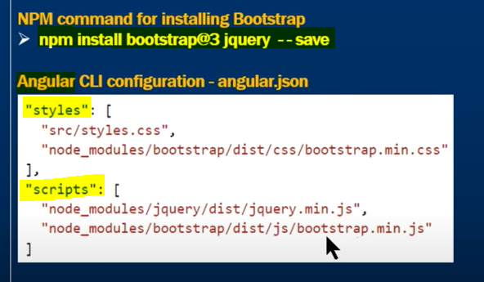

Angular Routing

Why a separate routing module Separation of concerns , Maitainability
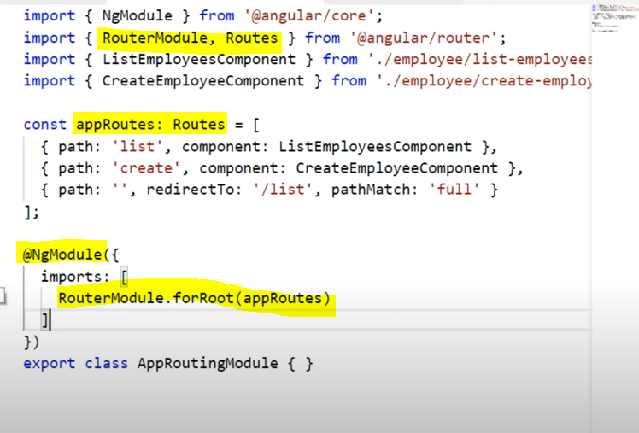

Mentioning router links in the component html

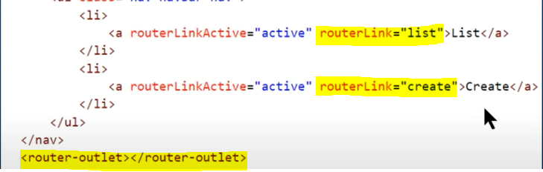
For the router-outlet , we need to export RouterModule

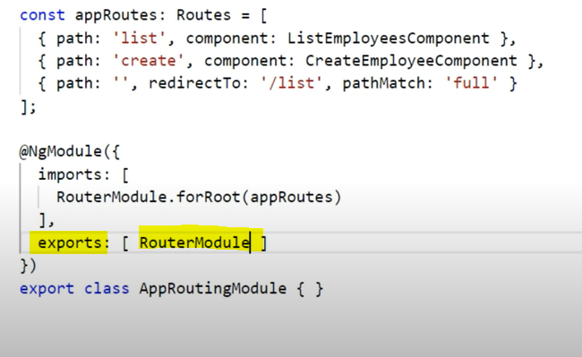

Angular Reactive Forms

Two ways to create forms in Angular
- Template driven forms – heavy on the template
- Reactive forms (model driven forms)

Template driven is for simple forms , Reactive forms are for complex forms

Classes for creating a form control tree
FormGroup
FormControl

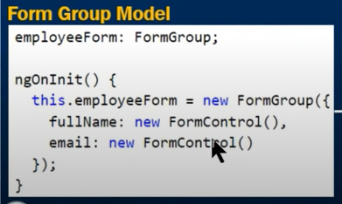

employeeForm : FormGroup

FormGroup collection of FormControl , it can also have another FormGroup nested within

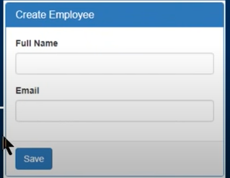

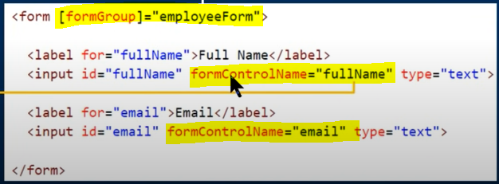

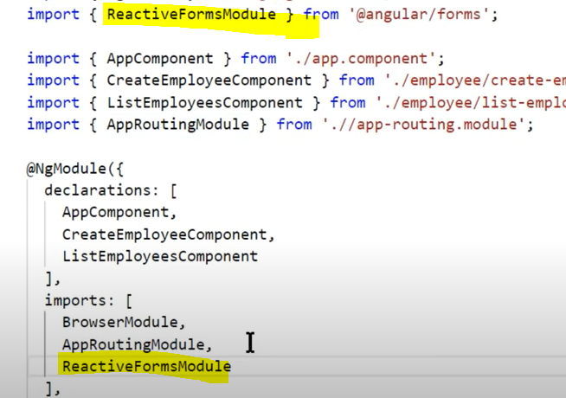

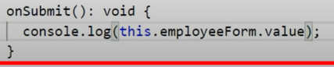

Both FormControl & FormGroup classes inherit from AbstractControl base class
The AbstractControl class has properties that help us track both FromControl and FormGroup value and state

The properties are value, error , valid , invalid , dirty , pristine , touched , untouched

FormControl tracks the value and state of an individual html element
FormGroup instance tracks the value and state of all the form controls in that group

this.employeeForm.touched
this.employeeForm.dirty

this.employeeForm.controls.fullName.value
or
this.employeeForm.get(“fullName”).value

This code works both in html and code
{{employeeForm.value}}

Angular Nested Form Groups

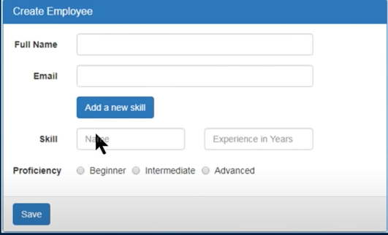

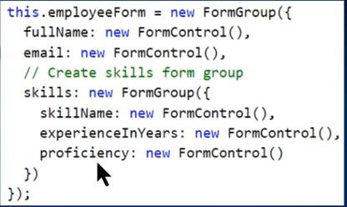

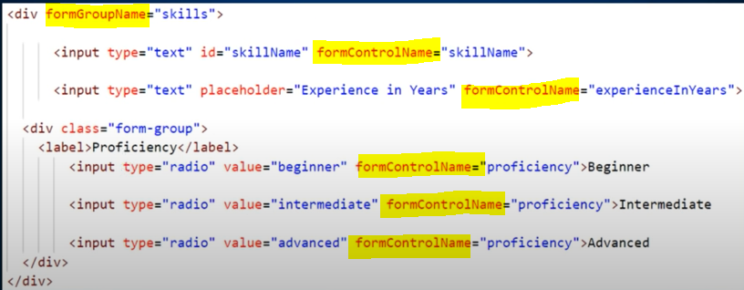

Angular setvalue and patchvalue

How to update html form with new data

(click)=”onLoadDataClick()”

this.employeeForm.setValue({
fullName:’Pragim technologies’,
email : ‘pragim@pragimtech.com’
skiells:{
sillName:’C#’,
experienceInYears : 5,
proficiency : ‘beginnner’
}
})

Only a subset of formControls , we use patchValue

this.employeeForm.patchValue({fullName:’Pragim tech’ , email : ‘pragim@pragimtech.com’})

Angular FormBuilder

Easier way of building reactive forms
The FormBuilder class has 3 methods : control(),group(),array()
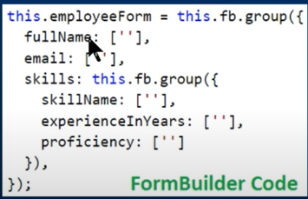

this.fb.group({fullName:[‘’],skillName:this.fb.group()})

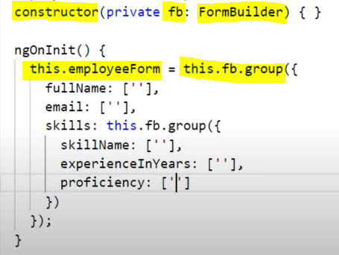

Angular Reactive Forms Validation

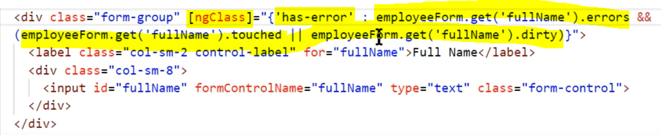

<span *ngIf=”employeeForm.get(‘fullName’).error.required”>

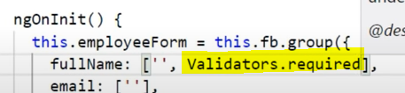

<span *ngIf=”employeeForm.get(‘fullName’).errors.minlength || employeeForm.get(‘fullName’).error.maxlength ”>

Angular Form Control ValueChanges

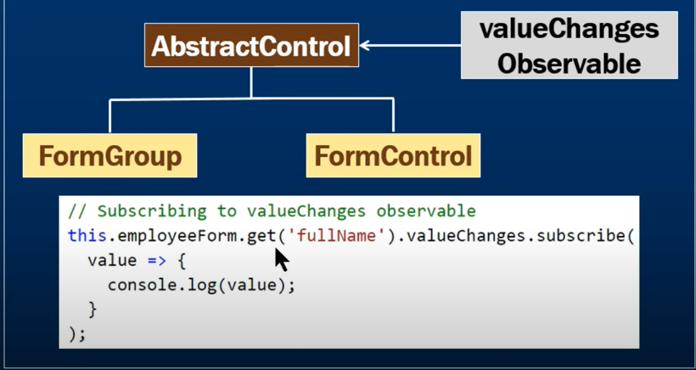

this.employeeForm.get(‘fullName’).valueChanges.subscribe(
value => {console.log(value)};
);

Same applies for formGroup also

Loop through all form controls in formgroup in reactive form

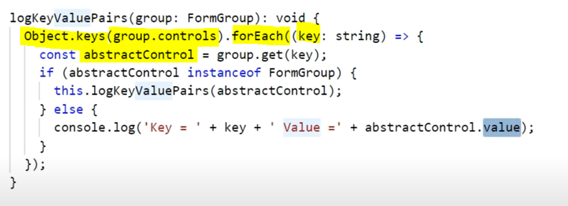

abstractControl.disable() //to disable all the controls

